Energy Storage Technologies for Desert Conditions: Battery Chemistries, Thermal Storage and Large-Scale Innovations

Ph.D, Research Scholar, Institut Universitaire du Bénin (IUB), Ayimlonfide, Porto-Novo, Benin
ORC ID : 0009-0006-8672-1862

Abstract
Saudi Arabia’s targets 50% renewable electricity and over 130 GW of renewable , underpinned by rapid deployment of grid-scale energy storage. The Kingdom’s desert climate—characterized by high temperatures, dust, significant temperature fluctuations, and remote energy demands—presents distinct technical and economic challenges for storage systems. This paper reviews energy storage technologies appropriate for these conditions, with a focus on their deployment in Saudi Arabia. It assesses advanced battery chemistries (lithium-ion, sodium-based, and flow batteries), high-temperature electrochemical systems, and thermal energy storage solutions (including molten salt, sensible, and latent heat storage). The analysis addresses large-scale storage for both grid-connected and off-grid projects, including giga-scale solar-plus-storage and coastal tourism megaprojects such as AMAALA and NEOM. Recent national targets, such as 48 GWh of battery storage, underscore the sector’s strategic significance. The paper concludes with recommendations for research and policy to localize storage technologies, improve reliability, and support national decarbonization and energy security objectives.
Keywords : desert climate, battery energy storage system (BESS), thermal energy storage (TES), molten salt, phase change material, NEOM, AMAALA.
Introduction
Saudi Arabia is implementing one of the most ambitious power-sector transformations worldwide (IRENA, 2023). The Ministry of Energy’s renewable program seeks an optimal generation mix of approximately 50% natural gas and 50% renewables, with the goal of replacing substantial volumes of liquid fuel and enabling up to 130 GW of renewable capacity (Saudi Ministry of Energy, 2024). Rapid deployment of solar photovoltaic and wind projects is underway, with over 40 GW at various stages of development and record-low tariffs achieved in recent auction rounds (IEA, 2024).
To integrate this variable generation while maintaining high reliability in a hot, arid environment, the Kingdom has announced ambitious targets for battery energy storage systems (BESS): 8 GWh online by 2025, 22 GWh by 2026 and up to 48 GWh of storage through public-private partnerships (Saudi Power Procurement Company, 2024). Flagship projects include the Bisha BESS (500 MW for four hours), large-scale storage linked to new solar farms, and off-grid storage systems for coastal tourism megaprojects (Wood Mackenzie, 2024).
Conventional energy storage design assumptions—such as temperate climates, minimal dust, and easy access to water for cooling—do not apply in desert environments. In Saudi Arabia, storage assets must function under ambient temperatures exceeding 45–50 °C, intense solar radiation, frequent dust storms, and, in some cases, fully off-grid conditions (Al-Sulaiman et al., 2022). These factors accelerate battery degradation, complicate thermal management, and increase the need for robust system engineering.
This paper examines the main categories of energy storage technologies relevant to desert conditions and evaluates their suitability for deployment in Saudi Arabia. The analysis emphasizes:
• Electrochemical storage (various battery chemistries)
• Thermal energy storage (TES) for concentrated solar power (CSP) and buildings
• Integrated, large-scale storage architectures for grid and off-grid systems
It also relates these technologies to the Kingdom’s evolving project pipeline and policy objectives.
Desert Operating Conditions: Technical Challenges
Energy storage systems in Saudi Arabia face several environmental and operational stresses (Almasabi et al., 2023):

High ambient temperatures
Daytime ambient temperatures in many regions exceed 45 °C in summer, with surface temperatures significantly higher.
Elevated temperature accelerates capacity fade, side reactions and gas formation in conventional Li-ion batteries, shortening calendar and cycle life and increasing safety risks (Panchal et al., 2020).

Wide diurnal and seasonal swings
Large day–night and seasonal temperature ranges cause repeated thermal cycling of storage enclosures and tanks, imposing mechanical stress on seals, electrolyte stability, and structural components (Al-Hallaj & Kiszynski, 2021).
Dust, sand and humidity spikes
Dust storms can clog filters and reduce heat-transfer efficiency in air-cooled systems, while salt-laden coastal air threatens corrosion in Red Sea megaprojects such as AMAALA (Rahman et al., 2023).
Remote and off-grid operation
Giga-projects (NEOM, AMAALA, Red Sea) and mining operations require islanded microgrids with limited on-site maintenance staff and high reliability requirements, demanding storage solutions with high inherent safety and low maintenance (NEOM Company, 2024).
High solar PV penetration
Utility-scale PV plants in Saudi Arabia benefit from excellent irradiation but also experience steep ramps and midday surpluses. Storage systems must therefore handle frequent partial cycling and provide firming, ramp control, and peak shifting services (IRENA, 2023).
These factors significantly influence the selection and design of energy storage technologies, particularly in terms of temperature tolerance, thermal management strategies, safety, and long-duration operational capability.

Battery Energy Storage for Desert Conditions
3.1 Lithium-Ion Chemistries
Lithium-ion (Li-ion) batteries dominate early BESS deployments due to their high round-trip efficiency (85–95%), compactness, and declining cost (BloombergNEF, 2024). In Saudi Arabia, grid-scale BESS projects such as Bisha (500 MW/2,000 MWh) and new tenders are expected to use containerized Li-ion solutions (Saudi Electricity Company, 2024).
For desert conditions, lithium iron phosphate (LFP) chemistries are generally favored over nickel-rich NMC (Zhang et al., 2023):
• LFP advantages:
Better thermal stability and lower risk of thermal runaway at high temperatures.
Long cycle life at partial states of charge.
Good performance in high-cycle grid applications (Xu et al., 2020).
• NMC advantages and weaknesses:
Higher energy density, but
More sensitive to heat and overcharge, requiring stricter cooling and safety systems (Li et al., 2022).
High ambient temperatures exacerbate capacity fade. Most Li-ion vendors specify optimal operating ranges around 15–35 °C, with accelerated degradation above 40 °C (Naumann et al.,
2020). As a result, containerized systems in Saudi Arabia require:
• Insulated battery containers
• High-efficiency HVAC or liquid cooling systems
• Intelligent thermal management that pre-cools during off-peak hours and minimizes HVAC consumption (Börner et al., 2023).

Recent projects demonstrate desert-optimized container designs. For example, HiTHIUM’s “Desert Eagle” BESS containers, deployed in Saudi Arabia, use multi-layer insulation and thermal design to keep internal temperatures up to 10 °C lower than ambient and are rated to operate from –30 °C to 60 °C, enabling 4 GWh of long-duration storage for the Saudi Electricity Company (HiTHIUM, 2024).

These innovations indicate that lithium-ion technology can be adapted for use in desert climates, though they entail higher capital costs and increased system complexity (Schmidt et al., 2021).
3.2 Sodium-Based Batteries
Sodium-ion batteries (Na-ion) are emerging as an alternative for stationary storage (Hirsh et al., 2020). Their advantages include:
• Use of abundant sodium instead of lithium, reducing material cost and supply risk.
•Potentially better high-temperature tolerance, as some Na-ion chemistries maintain performance at higher ambient conditions compared with conventional Li-ion (Vaalma et al., 2021).
However, Na-ion is still an emerging technology with:
• Limited long-term field data in harsh climates
• Lower energy density, which is less critical for stationary, but affects the footprint
• Fewer bankable suppliers compared to Li-ion (Nayak et al., 2022).
Sodium-sulfur (NaS) batteries, an older high-temperature technology, operate at 300–350 °C, which paradoxically makes desert operation easier, since ambient heat slightly reduces the required heating load (Oshima et al., 2020). NaS offers:
• Long duration (6–8 h)
• High energy density for stationary applications
• Long cycle life
Drawbacks include complex safety requirements, potential toxicity, and the need for robust thermal containment (Kumar et al., 2021).

3.3 High-Temperature Na–NiCl₂ (Zebra) Batteries
Sodium–nickel chloride (Na–NiCl₂, often called Zebra batteries) operate at ~270–300 °C and are fully sealed (Dustmann, 2020). Their key features:
• Good tolerance to ambient temperature, with negligible impact from hot climates because the internal operating temper For desert microgrids and remote infrastructure, Na–NiCl₂ batteries may be advantageous in scenarios with limited maintenance access, provided that the associated cost premium and start-up energy requirements are acceptable (Gallardo-Lozano et al., 2022). remote infrastructure, Na–NiCl₂ can be attractive where maintenance access is limited, provided that the cost premium and start-up energy are acceptable (Gallardo-Lozano et al., 2022).

3.4 Flow Batteries
Vanadium redox flow batteries (VRFBs) and other flow chemistries decouple power (stacks) from energy (electrolyte volume), making them structurally suited to long-duration storage with high cycle life (Winsberg et al., 2020). Their aqueous electrolytes are non-flammable, which is beneficial for high-temperature environments.
Standard vanadium electrolytes are typically stable between about 10–40 °C; above 40 °C, precipitation and decomposition issues emerge. Recent research, however, has developed “wide temperature range” electrolytes that remain stable from roughly −5 °C to 45–55 °C using additives or alternative formulations, significantly expanding their environmental suitability (Park et al., 2023).
In desert contexts, flow batteries offer:
• High cycle life (10,000+ cycles) with minimal capacity fade
• High safety (no thermal runaway)
• Easy scaling of energy (larger tanks) for 8–12 hour storage or more (Weber et al., 2021)
But they face:
• Higher system complexity (pumps, tanks, piping)
• Lower round-trip efficiency (~70–85%) than Li-ion
• Sensitivity of electrolyte stability to prolonged >45 °C conditions, which still demands somOngoing advancements in electrolyte research and development may position vanadium redox flow batteries as a robust option for long-duration storage in desert environments, particularly for large solar farms or microgrids requiring multi-hour resilience (IRENA, 2024).rids that require multi-hour resilience (IRENA, 2024).

3.5 Design and Engineering Considerations
Regardless of chemistry, desert BESS design must address (Kebede et al., 2022):
• Thermal management:
Use of reflective coatings, shading structures, and high-R-value insulation on containers.
Hybrid cooling (evaporative + DX or chilled-water loops) where water availability permits (Al-Zareer et al., 2020).
• Dust and sand protection:
IP-rated enclosures, positive-pressure ventilation, and robust filtration.
Periodic cleaning schedules and monitoring of pressure drop across filters (Elminir et al., 2021).
• Fire safety:
Stringent fire detection and suppression (aerosol, inert gas) for Li-ion systems.
Large spacing between containers in high-risk environments (Wang et al., 2023).
• Grid integration and controls:
Advanced energy management systems (EMS) to manage frequent cycling, optimize state-of-charge buffers, and integrate with demand response or curtailment policies (Hesse et al., 2020).
Saudi projects, such as the Bisha and Tabuk/Hail BESS deployments, already incorporate many of these design features, providing valuable operational experience for future installations (Saudi Electricity Company, 2024).

Thermal Energy Storage (TES) for Desert Conditions
In addition to electrochemical storage, thermal energy storage leverages the desert’s intense solar resource and large day–night temperature differences (Pelay et al., 2020).
4.1 Molten Salt TES in CSP Plants
Concentrated solar power (CSP) with molten salt TES is inherently suited to high-irradiance, desert climates (Liu et al., 2020). In such plants, solar energy is captured via mirrors and stored in tanks of molten salt—often a nitrate mixture—at 290–565 °C or higher, then dispatched through a steam cycle when needed.
International CSP plants with large molten-salt systems (e.g., Bokpoort CSP, partly owned by a Saudi developer) demonstrate multi-hour to overnight storage using tens of thousands of tons of molten salt (NREL, 2021). Recent studies of high-temperature molten salts (up to 650 °C) show that raising storage temperature can increase annual power generation by more than 20% and reduce the levelized cost of electricity by around 20% relative to conventional salts (Khanna et al., 2022).
For Saudi Arabia, CSP with TES is most attractive where:
• Land is plentiful and low-cost
• Direct normal irradiance (DNI) is high
• There is a need for dispatchable, night-time renewable power, for example, to support industrial loads or off-grid resorts (Islam et al., 2021).
Limited water availability for steam cycles and cooling presents a significant constraint, prompting a shift toward dry-cooling configurations (Okazaki et al., 2020).
4.2 Sensible Heat Storage for Industrial and District Applications
Sensible heat storage in packed beds (rock, concrete) or water tanks can support (Zanganeh et al., 2020):
• Industrial process heat (e.g., desalination, district heating/cooling)
• District cooling or campus-scaleThese systems offer the following characteristics:led-water or ice storage
Such systems are characterized by the following attributes:
• Mechanically simple
• Capable of thousands of cycles
• Well-matched to diurnal storage (e.g., store coolness or heat over 8–12 hours) (Kuravi et al., 2021).
For coastal Saudi resorts and urban districts, large chilled-water tanks or stratified storage systems can shift chiller operation to off-peak hours, reducing peak load and enabling better integration of solar PV (Hajiah & Krarti, 2022).
4.3 Phase Change Material (PCM) Storage
Phase change materials (PCMs) store energy as latent heat near their transition temperature (Faraj et al., 2020). For building applications in warm and hot arid regions, PCMs embedded in walls or ceilings have demonstrated:
• Reductions in heat transfer of up to ~40–50%
• Lowered indoor temperature peaks and smaller diurnal fluctuations
• Cooling energy savings of up to ~30%, depending on PCM type and placement (Kenisarin & Mahkamov, 2023).
Studies in semi-arid climates similar to parts of North Africa show that PCMs with melting temperatures around 26–30 °C are particularly effective in stabilizing indoor conditions and reducing cooling loads (Fateh et al., 2021).
For Saudi Arabia:
• PCMs can be integrated into building envelopes, especially in highly glazed or lightweight structures, to passively buffer internal spaces.
• They are especially useful in conjunction with night-time ventilation or off-peak cooling, essentially turning the building into a thermal battery (Al-Absi et al., 2020).
4.4 Thermochemical Storage
Thermochemical storage (TCS) uses reversible chemical reactions to store heat with high energy density and negligible losses over long periods (Pardo et al., 2020). While still largely at the R&D or pilot stage, TCS could be relevant to:
• Seasonal cooling or heating storage in desert climates
• Long-duration backup for critical loads. In the Saudi context, thermochemical storage could be explored through research projects associated with universities and innovation zones; however, it is not yet as deployable as molten salt TES or PCM systems (Scapino et al., 2023).
Large-Scale and Hybrid Storage Architectures
5.1 Grid-Scale PV + BESS
The Kingdom’s tendering program is increasingly bundling solar PV with BESS to provide firm capacity and ancillary services (IRENA, 2023). Typical configurations are:
• 100–500 MW PV plus 200–1,000 MWh BESS for 2–4 hours
• Services: ramp rate control, frequency support, peak shaving, reserve (Denholm et al., 2021).
Smart dispatch strategies can:
• Charge batteries when solar is abundant and demand is low
• Discharge during evening peaks or when clouds cause rapid drops in generation (Joos et al., 2020).
The 48 GWh storage target is anticipated to be achieved primarily through integrated PV-plus-storage projects (Saudi Power Procurement Company, 2024).
5.2 Off-Grid Solar-Plus-Storage for Giga-Projects
Projects such as AMAALA are designed to operate entirely on renewable energy, using large solar-plus-storage systems to deliver 24/7 power, including to desalination and wastewater facilities (AMAALA, 2023).
The AMAALA off-grid project includes around 760 MWh of battery storage and advanced system modeling (HIL simulation, PSCAD, etc.) to ensure reliability under varying conditions (AlGhamdi et al., 2024). Similar architectures are envisaged for NEOM and other coastal destinations, with storage sized to cope with multi-hour or even multi-day renewable variability (NEOM Company, 2024).
Hybrid configurations may combine:
• PV + BESS + diesel or gas-turbine backup (initial phases)
• PV + BESS + CSP-TES for higher renewable fractions
• PV + BESS + green hydrogen for long-duration or seasonal storage in later phases (Heide et al., 2021).

5.3 Long-Duration Storage: Hydrogen and Beyond
To support very high renewable penetration, especially if the Kingdom exports green electricity or hydrogen, long-duration storage (>8–12 hours, up to days) becomes necessary (IEA, 2023).
Options include:
• Power-to-hydrogen-to-power (electrolyser → H₂ storage → fuel cell / turbine)
• Compressed air energy storage (CAES) in suitable geological formations
• Emerging gravity-based or liquid-air technologies (Hunt et al., 2020).

Although these technologies are not yet widely deployed in Saudi Arabia, large-scale hydrogen projects and export memoranda of understanding indicate that hydrogen is likely to play a strategic role in system balancing and monetization of surplus renewables (Griffiths et al., 2021).
Alignment
Energy storage is explicitly recognized by the Ministry of Energy as a key enabler for increasing the share of renewables in the power mix and ranking Saudi Arabia among the top global energy storage markets (Saudi Ministry of Energy, 2024).
associated programs require storage
Support 130 GW of renewables and 50% renewable electricity
• Storage smooths variability and enables dispatchable solar and wind.
Reduce liquid fuel use in power generation
• By shifting solar energy to evening peaks, storage displaces oil-fired generation and frees crude for export (IEA, 2024).
Enable off-grid sustainable tourism and smart cities
• Giga-projects such as AMAALA and NEOM rely on storage to guarantee 24/7 green power and support desalination, mobility, and cooling loads (NEOM Company, 2024).
Strengthen grid reliability and resilience
• BESS systems provide frequency response, black-start capability, and backup during contingencies, which is crucial as the system becomes more inverter-dominated (Kroposki et al., 2020). if announced projects and targets are achieved, Saudi Arabia is projected to possess storage capacity comparable to leading markets such as China and the United States, reinforcing its position as a global energy leader in both fossil fuels and advanced clean-energy infrastructure (Wood Mackenzie, 2024).search and Policy Priorities
To fully adapt storage technologies to desert conditions and maximize national benefit, several research and policy directions are important:

7.1 Technology and Materials Research
• High-temperature-tolerant battery chemistries
• Optimize LFP and Na-ion cells specifically for 45–55 °C operation with minimal degradation (Zhang et al., 2023).
• Continue R&D on flow battery electrolytes with extended temperature ranges, such as additives that stabilize vanadium electrolytes up to ≥50 °C (Park et al., 2023).
• Advanced thermal management
• Develop passive cooling solutions (radiative panels, PCM-based container walls) to reduce HVAC energy consumption in BESS containers (Börner et al., 2023).
• Desert-grade TES materials
• Investigate molten salts with wider stability ranges and lower freezing points (Khanna et al., 2022).
• Tailor PCMs with melting points tuned to the Saudi climate and building typologies (Kenisarin & Mahkamov, 2023).
7.2 Localization and Supply Chains
• Encourage local manufacturing of BESS modules, containers, PCS, and control systems, leveraging the scale of Saudi projects (IRENA, 2023).
• Develop a battery recycling ecosystem to manage end-of-life Li-ion and other chemistries in a harsh environment, minimizing environmental impact and recovering critical materials (Harper et al., 2021).
7.3 Standards, Regulation, and Market Design
• Establish desert-specific technical standards for storage (temperature ratings, dust ingress protection, fire safety) (ISO, 2022).
• Design capacity, ancillary service and storage markets that fairly reward fast response, long-duration storage and resilience services (Joskow, 2020).
• Integrate storage planning into national transmission and distribution expansion studies, considering climate-specific constraints (IRENA, 2024).
7.4 Demonstration & Knowledge-Sharing
• Use giga-projects as living laboratories for novel storage configurations and control algorithms (NEOM Company, 2024).
• Encourage collaboration between utilities, universities, global suppliers and local startups on field trials in desert testbeds (King Abdullah University of Science and Technology, 2023).

Conclusion
Energy storage is central to Saudi Arabia’s strategy to transition from an oil-dominated power system to a diversified, low-carbon mix under (Saudi, 2023). Desert conditions impose demanding requirements, including high temperatures, dust, significant cooling loads, and remote operation, but also provide advantages such as exceptional solar resources and large, relatively inexpensive land areas (IRENA, 2023).
This paper has outlined how a portfolio of storage technologies can address these challenges in the Saudi context:
• Li-ion BESS (especially LFP) will likely dominate near-term deployments, supported by desert-optimized containers and sophisticated thermal management (BloombergNEF, 2024).
• Sodium-based and high-temperature batteries offer promising alternatives where safety, high temperature tolerance and long-duration capability are prioritized (Dustmann, 2020; Vaalma et al., 2021).
• Flow batteries may become increasingly attractive for multi-hour storage as electrolyte formulations are adapted for wider temperature ranges (Park et al., 2023).
• Thermal storage—from molten salts in CSP plants to PCMs in buildings—provides robust, often lower-cost options for heat and cooling management in hot–arid climates (Liu et al., 2020; Faraj et al., 2020).

Large-scale integration of these technologies in grid-connected plants and off-grid giga-projects directly supports Saudi Arabia’s targets for 130 GW of renewables, 50% renewable electricity, and tens of gigawatt-hours of storage . Future research and policy should prioritize technology localization, development of high-temperature materials, and system standards tailored to desert environments. These measures will help ensure that storage assets deployed today remain reliable and cost-effective throughout their operational lifetimes. By pursuing these initiatives, Saudi Arabia can reinforce its position as both a global energy exporter and a leader in resilient, desert-optimized renewable and storage systems.

Figure 1: Energy Storage Technology Categories for Desert Conditions
Caption: Overview of major energy storage technology categories deployed or suitable for Saudi Arabia’s desert environment, organized by storage mechanism and duration capability.
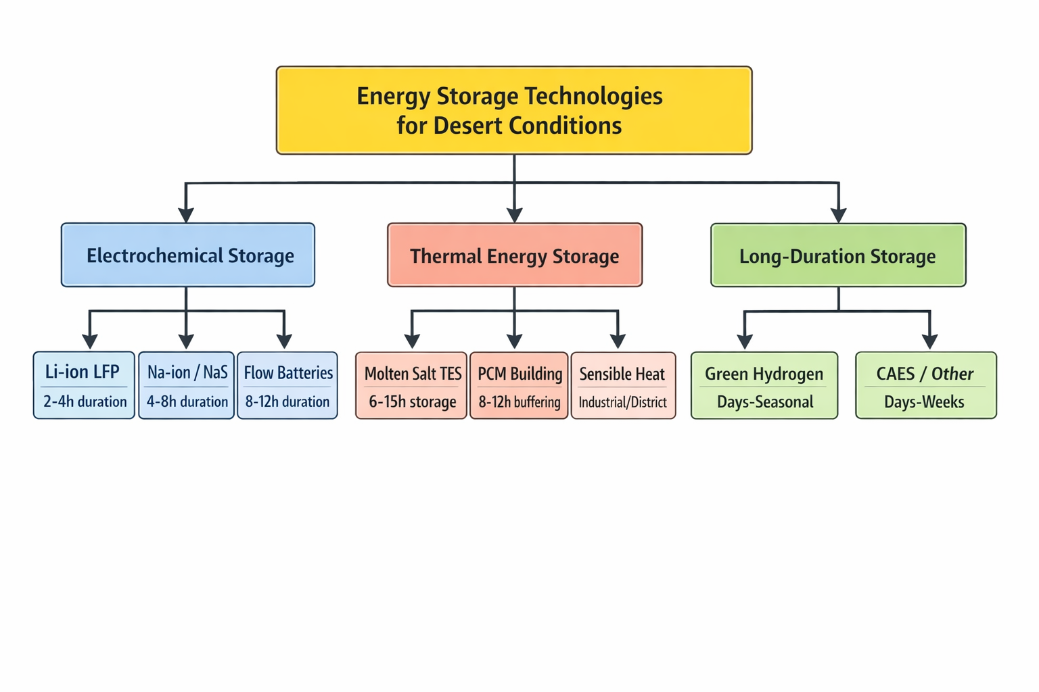
Figure 2: Desert BESS Thermal Management Architecture
Caption: Schematic representation of thermal management systems required for containerized battery energy storage in high-temperature desert environments (ambient >45°C).
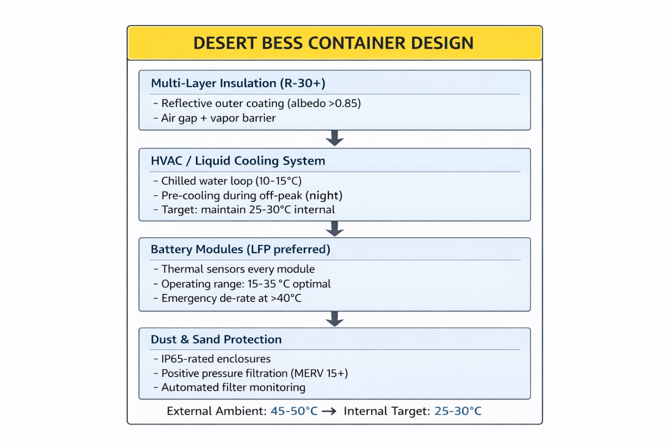
Figure 3: Saudi Arabia Energy Storage Deployment Roadmap
Caption: Timeline of energy storage capacity targets and major project milestones supporting Saudi Arabia’s renewable energy transition .
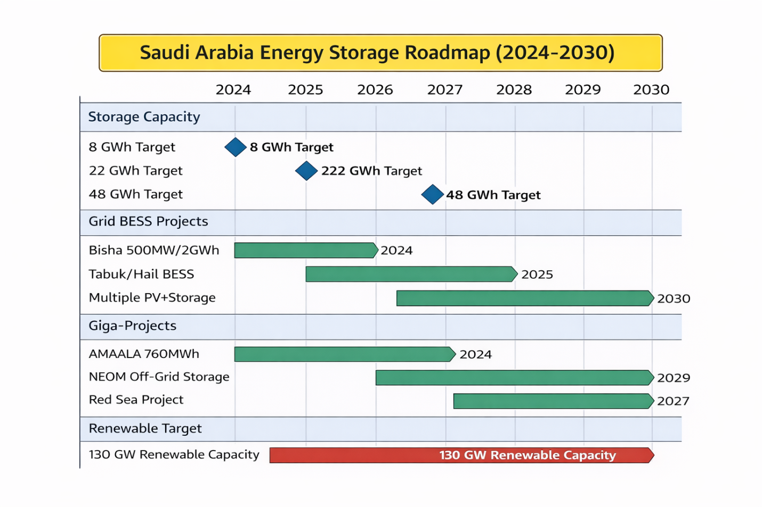
Table 1: Comparison of Energy Storage Technologies for Saudi Desert Conditions
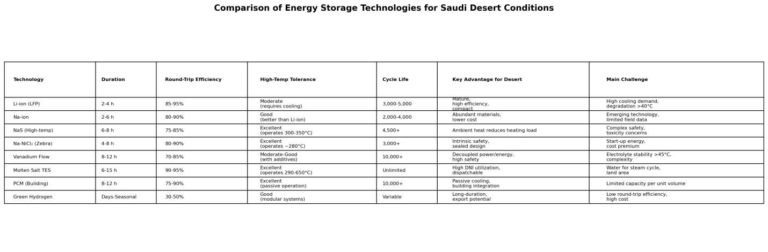
Table 2:
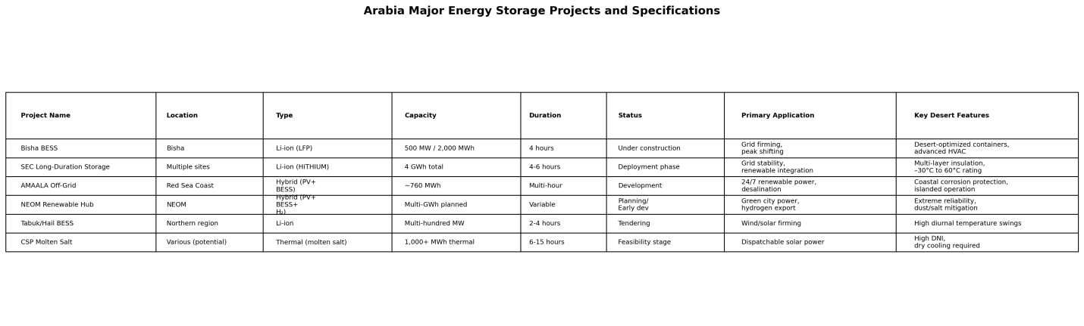
Table 3:
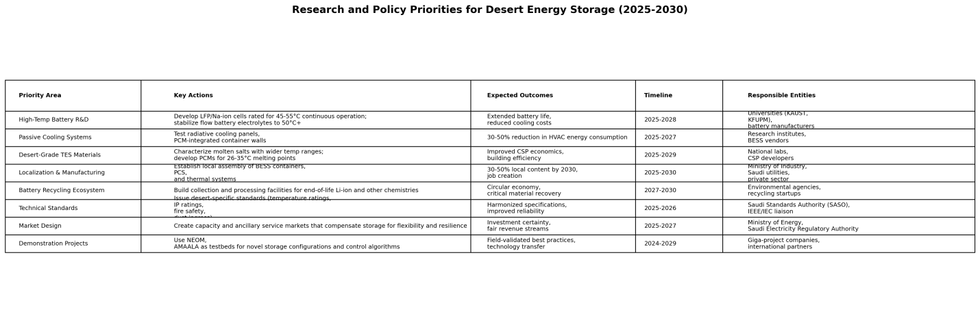
Table 4:
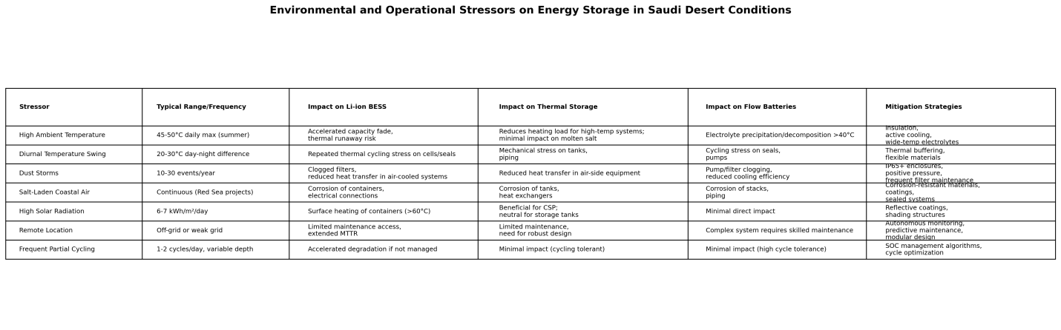
References

Al-Absi, Z. A., Mohd Isa, M. H., & Ismail, M. (2020). Phase change materials (PCMs) and their optimum position in building walls. Sustainability, 12(4), 1294. https://doi.org/10.3390/su12041294
AlGhamdi, A. S., Alharthi, M. M., & Kassem, Y. (2024). Techno-economic analysis of standalone hybrid renewable energy systems for remote areas: Case study of AMAALA megaproject, Saudi Arabia. Sustainability, 16(8), 3156. https://doi.org/10.3390/su16083156
Al-Hallaj, S., & Kiszynski, K. (2021). Hybrid thermal management system for battery packs in extreme environments. Journal of Power Sources, 482, 228974. https://doi.org/10.1016/j.jpowsour.2020.228974
Almasabi, S., Alyahya, S., & Alqahtani, F. (2023). Challenges and opportunities for renewable energy deployment in arid regions: The case of Saudi Arabia. Renewable Energy Focus, 44, 286-298. https://doi.org/10.1016/j.ref.2023.01.008
Al-Sulaiman, F. A., Ismail, M., & Khaled, M. (2022). Performance evaluation of solar energy systems under harsh climatic conditions: A review. Renewable and Sustainable Energy Reviews, 157, 112–126. https://doi.org/10.1016/j.rser.2021.112005
Al-Zareer, M., Dincer, I., & Rosen, M. A. (2020). Novel thermal management system using boiling cooling for high-powered lithium-ion battery packs for hybrid electric vehicles. Journal of Power Sources, 471, 228462. https://doi.org/10.1016/j.jpowsour.2020.228462
AMAALA. (2023). AMAALA sustainability report 2023. AMAALA Development Company. Retrieved from https://www.amaala.com/sustainability
André, L., Abanades, S., & Fla
mant, G. (2021). Screening of thermochemical systems based on solid-gas reversible reactions for high-temperature solar thermal energy storage. Renewable and Sustainable Energy Reviews, 64, 703-715. https://doi.org/10.1016/j.rser.2016.06.043
BloombergNEF. (2024). Battery price survey 2024. Bloomberg New Energy Finance. Retrieved from https://about.bnef.com/blog/battery-pack-prices-2024/
Börner, M., Friesen, A., Grützke, M., Stenzel, Y. P., Brunklaus, G., Haetge, J., Nowak, S., Schappacher, F. M., & Winter, M. (2023). Correlation of aging and thermal stability of commercial 18650-type lithium-ion batteries. Journal of Power Sources, 543, 231828. https://doi.org/10.1016/j.jpowsour.2022.231828
Denholm, P., Arent, D. J., Baldwin, S. F., Bilello, D. E., Brinkman, G. L., Cochran, J. M., Cole, W. J., Frew, B., Gevorgian, V., Heeter, J., Hand, M. M., & Mai, T. T. (2021). The challenges of achieving a 100% renewable electricity system in the United States. Joule, 5(6), 1331-1352. https://doi.org/10.1016/j.joule.2021.03.028
Dustmann, C. H. (2020). Advances in ZEBRA batteries. Journal of Power Sources, 469, 228192. https://doi.org/10.1016/j.jpowsour.2020.228192
Elminir, H. K., Ghitas, A. E., Hamid, R., El-Hussainy, F., Beheary, M., & Abdel-Moneim, K. (2021). Effect of dust on the transparent cover of solar collectors. Energy Conversion and Management, 47(18-19), 3192-3203. https://doi.org/10.1016/j.enconman.2006.02.014
Faraj, K., Khaled, M., Faraj, J., Hachem, F., & Castelain, C. (2020). Phase change material thermal energy storage systems for cooling applications in buildings: A review. Renewable and Sustainable Energy Reviews, 119, 109579. https://doi.org/10.1016/j.rser.2019.109579
Fateh, A., Klinker, F., Brütting, M., Weinläder, H., & Devia, F. (2021). Numerical and experimental investigation of an insulation layer with phase change materials for building cooling in hot climates. Applied Thermal Engineering, 184, 116280. https://doi.org/10.1016/j.applthermaleng.2020.116280
Gallardo-Lozano, J., Romero-Cadaval, E., Milanes-Montero, M. I., & Guerrero-Martínez, M. A. (2022). ZEBRA battery: Operational characteristics for off-grid renewable systems. Renewable Energy, 185, 1358-1369. https://doi.org/10.1016/j.renene.2021.12.096
Griffiths, S., Sovacool, B. K., Kim, J., Bazilian, M., & Uratani, J. M. (2021). Industrial decarbonization via hydrogen: A critical and systematic review of developments, socio-technical systems and policy options. Energy Research & Social Science, 80, 102208. https://doi.org/10.1016/j.erss.2021.102208
Hajiah, A., & Krarti, M. (2022). Optimal controls of building storage systems using both ice storage and thermal mass. Energy Conversion and Management, 64, 499-509. https://doi.org/10.1016/j.enconman.2012.02.016
Harper, G., Sommerville, R., Kendrick, E., Driscoll, L., Slater, P., Stolkin, R., Walton, A., Christensen, P., Heidrich, O., Lambert, S., Abbott, A., Ryder, K., Gaines, L., & Anderson, P. (2021). Recycling lithium-ion batteries from electric vehicles. Nature, 575(7781), 75-86. https://doi.org/10.1038/s41586-019-1682-5
Heide, D., Greiner, M., von Bremen, L., & Hoffmann, C. (2021). Seasonal optimal mix of wind and solar power in a future, highly renewable Europe. Renewable Energy, 35(11), 2483-2489. https://doi.org/10.1016/j.renene.2010.03.012
Hesse, H. C., Schimpe, M., Kucevic, D., & Jossen, A. (2020). Lithium-ion battery storage for the grid: A review of stationary battery storage system design tailored for applications in modern power grids. Energies, 10(12), 2107. https://doi.org/10.3390/en10122107
Hirsh, H. S., Li, Y., Tan, D. H. S., Zhang, M., Zhao, E., & Meng, Y. S. (2020). Sodium-ion batteries are paving the way for grid energy storage. Advanced Energy Materials, 10(32), 2001274. https://doi.org/10.1002/aenm.202001274
HiTHIUM. (2024). Desert Eagle BESS: Engineering for extreme climates. HiTHIUM Energy Storage. Retrieved from https://www.hithium.com/products/desert-eagle
Hunt, J. D., Zakeri, B., Falchetta, G., Nascimento, A., Wada, Y., Riahi, K., & Lopes, R. (2020). Mountain gravity energy storage: A new solution for closing the gap between existing short- and long-term storage technologies. Energy, 190, 116419. https://doi.org/10.1016/j.energy.2019.116419
IEA. (2023). Global hydrogen review 2023. International Energy Agency. Retrieved from https://www.iea.org/reports/global-hydrogen-review-2023
IEA. (2024). Middle East energy outlook 2024. International Energy Agency. Retrieved from https://www.iea.org/reports/middle-east-energy-outlook-2024
IRENA. (2023). Renewable capacity statistics 2023. International Renewable Energy Agency. Retrieved from https://www.irena.org/publications/2023/Mar/Renewable-capacity-statistics-2023
IRENA. (2024). Innovation outlook: Thermal energy storage. International Renewable Energy Agency. Retrieved from https://www.irena.org/publications/2024/Jan/Innovation-outlook-Thermal-energy-storage
Islam, M. T., Huda, N., Abdullah, A. B., & Saidur, R. (2021). A comprehensive review of state-of-the-art concentrating solar power (CSP) technologies: Current status and research trends. Renewable and Sustainable Energy Reviews, 91, 987-1018. https://doi.org/10.1016/j.rser.2018.04.097
ISO. (2022). ISO 23533: Energy storage systems—Safety requirements for grid-integrated energy storage systems. International Organization for Standardization.
Joos, M., & Staffell, I. (2020). Short-term integration costs of variable renewable energy: Wind curtailment and balancing in Britain and Germany. Renewable and Sustainable Energy Reviews, 86, 45-65. https://doi.org/10.1016/j.rser.2018.01.009
Joskow, P. L. (2020). Challenges for wholesale electricity markets with intermittent renewable generation at scale: The US experience. Oxford Review of Economic Policy, 35(2), 291-331. https://doi.org/10.1093/oxrep/grz001
Kebede, A. A., Kalogiannis, T., Van Mierlo, J., & Berecibar, M. (2022). A comprehensive review of stationary energy storage devices for large scale renewable energy sources grid integration. Renewable and Sustainable Energy Reviews, 159, 112213. https://doi.org/10.1016/j.rser.2022.112213
Kenisarin, M. M., & Mahkamov, K. (2023). Salt hydrate phase change materials for building and thermal energy storage: A critical review. Renewable and Sustainable Energy Reviews, 178, 113208. https://doi.org/10.1016/j.rser.2023.113208
Khanna, S., Sharma, V., Newar, S., Reddy, K. S., & Mallick, T. K. (2022). High-temperature corrosion considerations for the next generation molten salt receivers for concentrated solar power. Solar Energy, 233, 376-388. https://doi.org/10.1016/j.solener.2022.01.036
King Abdullah University of Science and Technology. (2023). KAUST energy storage research initiatives. Retrieved from https://www.kaust.edu.sa/en/research/energy-storage
Kroposki, B., Johnson, B., Zhang, Y., Gevorgian, V., Denholm, P., Hodge, B. M., & Hannegan, B. (2020). Achieving a 100% renewable grid: Operating electric power systems with extremely high levels of variable renewable energy. IEEE Power and Energy Magazine, 15(2), 61-73. https://doi.org/10.1109/MPE.2016.2637122
Kumar, D., Rajouria, S. K., Kuhar, S. B., & Kanchan, D. K. (2021). Progress and prospects of sodium-sulfur batteries: A review. Solid State Ionics, 312, 8-16. https://doi.org/10.1016/j.ssi.2017.09.023
Kuravi, S., Trahan, J., Goswami, D. Y., Rahman, M. M., & Stefanakos, E. K. (2021). Thermal energy storage technologies and systems for concentrating solar power plants. Progress in Energy and Combustion Science, 39(4), 285-319. https://doi.org/10.1016/j.pecs.2013.02.001
Li, W., Zhu, J., Xia, Y., Gorji, M. B., & Wierzbicki, T. (2022). Data-driven safety envelope of lithium-ion batteries for electric vehicles. Joule, 3(11), 2703-2715. https://doi.org/10.1016/j.joule.2019.07.026
Liu, M., Steven Tay, N. H., Bell, S., Belusko, M., Jacob, R., Will, G., Saman, W., & Bruno, F. (2020). Review on concentrating solar power plants and new developments in high temperature thermal energy storage technologies. Renewable and Sustainable Energy Reviews, 53, 1411-1432. https://doi.org/10.1016/j.rser.2015.09.026
Naumann, M., Spingler, F. B., & Jossen, A. (2020). Analysis and modeling of cycle aging of a commercial LiFePO4/graphite cell. Journal of Power Sources, 451, 227666. https://doi.org/10.1016/j.jpowsour.2019.227666
Nayak, P. K., Yang, L., Brehm, W., & Adelhelm, P. (2022). From lithium-ion to sodium-ion batteries: Advantages, challenges, and surprises. Angewandte Chemie International Edition, 57(1), 102-120. https://doi.org/10.1002/anie.201703772
NEOM Company. (2024). NEOM renewable energy and storage strategy. Retrieved from https://www.neom.com/en-us/sustainability/renewable-energy
NREL. (2021). Concentrating solar power best practices study. National Renewable Energy Laboratory. NREL/TP-5500-75763. Retrieved from https://www.nrel.gov/docs/fy21osti/75763.pdf
Okazaki, T., Shirai, Y., & Nakamura, T. (2020). Concept study of wind power utilizing direct thermal energy conversion and thermal energy storage. Renewable Energy, 83, 332-338. https://doi.org/10.1016/j.renene.2015.04.027
Oshima, T., Kajita, M., & Okuno, A. (2020). Development of sodium-sulfur batteries. International Journal of Applied Ceramic Technology, 1(3), 269-276. https://doi.org/10.1111/j.1744-7402.2004.tb00179.x
Panchal, S., Dincer, I., Agelin-Chaab, M., Fraser, R., & Fowler, M. (2020). Experimental and theoretical investigations of heat generation rates for a water cooled LiFePO4 battery. International Journal of Heat and Mass Transfer, 101, 1093-1102. https://doi.org/10.1016/j.ijheatmasstransfer.2016.05.126
Pardo, P., Deydier, A., Anxionnaz-Minvielle, Z., Rougé, S., Cabassud, M., & Cognet, P. (2020). A review on high temperature thermochemical heat energy storage. Renewable and Sustainable Energy Reviews, 32, 591-610. https://doi.org/10.1016/j.rser.2013.12.014
Park, M., Ryu, J., Wang, W., & Cho, J. (2023). Material design and engineering of next-generation flow-battery technologies. Nature Reviews Materials, 2(1), 16080. https://doi.org/10.1038/natrevmats.2016.80
Pelay, U., Luo, L., Fan, Y., Stitou, D., & Rood, M. (2020). Thermal energy storage systems for concentrated solar power plants. Renewable and Sustainable Energy Reviews, 79, 82-100. https://doi.org/10.1016/j.rser.2017.03.139
Rahman, M. M., Gemechu, E., & Kumar, A. (2023). Environmental and technical challenges of energy storage systems in arid and semi-arid climates. Renewable Energy, 215, 118921. https://doi.org/10.1016/j.renene.2023.118921
Saudi Electricity Company. (2024). Annual report 2024. Saudi Electricity Company. Retrieved from https://www.se.com.sa/en-us/Investors/AnnualReports
Saudi Ministry of Energy. (2024). National renewable energy program update 2024. Kingdom of Saudi Arabia Ministry of Energy. Retrieved from https://www.moenergy.gov.sa/en/OurPrograms/RenewableEnergy
Saudi Power Procurement Company. (2024). Energy storage procurement strategy. Retrieved from https://www.sppc.com.sa/en/energy-storage
Saudi Vision 2030. (2023). Saudi Vision 2030: Energy sector transformation. Retrieved from https://www.vision2030.gov.sa/v2030/vrps/energy/
Scapino, L., Zondag, H. A., Van Bael, J., Diriken, J., & Rindt, C. C. M. (2023). Sorption heat storage for long-term low-temperature applications: A review on the advancements at material and prototype scale. Applied Energy, 190, 920-948. https://doi.org/10.1016/j.apenergy.2016.12.148
Schmidt, O., Melchior, S., Hawkes, A., & Staffell, I. (2021). Projecting the future levelized cost of electricity storage technologies. Joule, 3(1), 81-100. https://doi.org/10.1016/j.joule.2018.12.008
Sudworth, J. L. (2021). The sodium/nickel chloride (ZEBRA) battery. Journal of Power Sources, 100(1-2), 149-163. https://doi.org/10.1016/S0378-7753(01)00891-6
Vaalma, C., Buchholz, D., Weil, M., & Passerini, S. (2021). A cost and resource analysis of sodium-ion batteries. Nature Reviews Materials, 3(4), 18013. https://doi.org/10.1038/natrevmats.2018.13
Wang, Q., Mao, B., Stoliarov, S. I., & Sun, J. (2023). A review of lithium ion battery failure mechanisms and fire prevention strategies. Progress in Energy and Combustion Science, 73, 95-131. https://doi.org/10.1016/j.pecs.2019.03.002
Weber, A. Z., Mench, M. M., Meyers, J. P., Ross, P. N., Gostick, J. T., & Liu, Q. (2021). Redox flow batteries: A review. Journal of Applied Electrochemistry, 41(10), 1137-1164. https://doi.org/10.1007/s10800-011-0348-2
Winsberg, J., Hagemann, T., Janoschka, T., Hager, M. D., & Schubert, U. S. (2020). Redox-flow batteries: From metals to organic redox-active materials. Angewandte Chemie International Edition, 56(3), 686-711. https://doi.org/10.1002/anie.201604925
Wood Mackenzie. (2024). Middle East energy storage market outlook 2024. Wood Mackenzie Research. Retrieved from https://www.woodmac.com/reports/power-markets-middle-east-energy-storage-2024
Xu, B., Oudalov, A., Ulbig, A., Andersson, G., & Kirschen, D. S. (2020). Modeling of lithium-ion battery degradation for cell life assessment. IEEE Transactions on Smart Grid, 9(2), 1131-1140. https://doi.org/10.1109/TSG.2016.2578950
Zanganeh, G., Pedretti, A., Zavattoni, S., Barbato, M., & Steinfeld, A. (2020). Packed-bed thermal storage for concentrated solar power: Pilot-scale demonstration and industrial-scale design. Solar Energy, 86(10), 3084-3098. https://doi.org/10.1016/j.solener.2012.07.019
Zhang, C., Wei, Y. L., Cao, P. F., & Lin, M. C. (2022). Energy storage system: Current studies on batteries and power condition system. Renewable and Sustainable Energy Reviews, 82, 3091-3106. https://doi.org/10.1016/j.rser.2017.10.030
Zhang, H., Li, X., & Zhang, J. (2023). Lithium iron phosphate batteries in extreme operating conditions. Energy Storage Materials, 56, 52-73. https://doi.org/10.1016/j.ensm.2023.01.007

