Hybrid Solar–Wind–Storage Microgrids for Remote Regions in Saudi Arabia:
Enabling NEOM and Red Sea Vision 2030 Energy Goals

Ph.D, Research Scholar, Institut Universitaire du Bénin (IUB), Ayimlonfide, Porto-Novo, Benin
ORC ID : 0009-0006-8672-1862
Abstract

Saudi Arabia’s Vision 2030 is reshaping the power sector by targeting an electricity mix of roughly 50% renewables and 50% gas by 2030, while phasing down liquid fuels used for generation. In parallel, giga-projects such as NEOM and the Red Sea Project are expected to operate at or near 100% renewable energy, which makes smart microgrids with distributed solar, wind, and large-scale storage a practical pathway.
This paper examines how hybrid solar–wind–battery microgrids can support remote, coastal, and high-value developments in the Kingdom, with emphasis on NEOM and Red Sea use cases. It first summarizes the national policy direction and renewable rollout, then consolidates international findings on microgrid architectures, energy management, and techno-economic outcomes for remote electrification. Saudi examples are discussed, including the Red Sea off-grid solar-plus-storage system and NEOM’s plans for an integrated renewable grid linked to a green-hydrogen ecosystem.
A design framework is proposed covering resource assessment, system sizing, storage selection, and layered control. The techno-economic evaluation approach uses net present cost (NPC), levelized cost of electricity (LCOE), renewable fraction, loss of load probability (LOLP), and CO₂ abatement. Evidence from recent regional modeling and Saudi-relevant studies indicates that well-sized hybrid systems can cut diesel use by 70–100%, reduce lifecycle emissions by over 60%, and deliver reliability suited to tourism, industry, and critical infrastructure. Key barriers and research needs include islanded grid-code alignment, bankable revenue models, cyber-physical security, extreme-climate operation, and AI-enabled energy management.

Keywords: Microgrids; hybrid renewables; solar–wind–storage; NEOM; Red Sea Project; Vision 2030; resilience; remote electrification.

1. Introduction
While access to reliable, adequate, and sustainable energy is a cornerstone of socio-economic development, the highest costs and poorest quality of service have often been reported for remote and sparsely populated regions. Thousands of remote communities around the world rely on diesel generation for their main source of electricity, facing high fuel logistics costs, exposure to volatile prices, and significant greenhouse gas emissions. Hybrid renewable microgrids, from local solar PV and wind turbines to energy storage systems, have thus emerged as one of the key avenues behind transforming those areas with reduced carbon emissions while enhancing resilience.
Saudi Arabia is pursuing both national-scale and project-scale energy transitions. At the national level, Vision 2030 aims to achieve an optimal power mix in which renewables and natural gas each supply approximately 50% of electricity generation, thereby reducing the consumption of liquid fuels in power plants. At the project level, flagship giga-projects such as NEOM and the Red Sea Project are designed to operate entirely on renewable energy, serving as global exemplars for sustainable tourism, advanced industry, and smart-city infrastructure. These projects are situated in remote or coastal regions with limited existing grid infrastructure, making them suitable testbeds for high-penetration hybrid microgrids.
Specifically, the Red Sea Project now hosts a 400 MW PV and 1.3 GWh battery energy storage microgrid, which supplies the entire development off-grid, reportedly over 1 TWh of green electricity annually and representing the world's largest solar-plus-storage microgrid (Huawei Digital Power, 2024). NEOM, through its energy company ENOWA, is developing an at-scale 100% renewable energy system incorporating smart high-voltage grids, large wind and solar fleets, and the world's largest green hydrogen plant. These directly support the goals of Vision 2030 while providing practical laboratories for microgrid innovation under extreme desert conditions.
This paper examines the configuration of hybrid solar–wind–storage microgrids to address the energy needs of remote regions in Saudi Arabia, with a particular focus on NEOM and developments surrounding the Red Sea. The analysis is structured around three central research questions:
1. What architectures and control strategies are most suitable for hybrid microgrids in remote Saudi contexts?
2. How do such microgrids contribute towards resilience, reliability, and fossil-fuel displacement in line with Vision 2030?
3. What are the policy and research actions that will be required to scale the deployment of microgrids in these remote areas of the Kingdom?
2. Saudi Vision 2030 and the Renewable Energy Context
2.1 Vision 2030 targets and National Renewable Energy Program
Saudi Vision 2030 and associated programs, such as the National Renewable Energy Program, bind the Kingdom to a rapid energy transition. Official statements and recent analyses suggest that by 2030, it will have an electricity mix of about 50% natural gas and 50% renewables, with carbon emissions reduced by around 278 Mt per year. This is underpinned by the ambition that Saudi Arabia has announced to reach about 130 GW of renewable capacity by 2030, from a few gigawatts today. Utility-scale projects, like Sudair, Al-Sadawi, Al-Massaa, Al-Hanakiya, and Rabigh, are being developed across different regions, each with 1.5 GW (Saudi Gazette, 2025). Although these will be grid-connected plants, the technology base, supply chains, and financing models they will create are also going to be useful for the deployment of remote micro-grids.
2.2 Giga-projects as microgrid laboratories: NEOM and the Red Sea
NEOM, stretching along the Gulf of Aqaba and well into the northwest desert, is envisioned as a diversified future city to house 9-10 million people, with a complete reliance on renewables (NEOM, 2023). As a subsidiary, ENOWA is working on what is claimed to be the world’s first renewable high-voltage smart grid that would incorporate massive solar, wind, storage, and digital intelligence to deliver 100% green power using a more compact footprint in the transmission corridor (NEOM, 2024). Meanwhile, a new production facility is under construction by NEOM’s Green Hydrogen Company (NGHC) to incorporate up to 4GW of dedicated wind and solar generation, targeting a production output of 600 tons per day of green hydrogen that would be exported in green ammonia form (NEOM, 2024).
The Red Sea Project, an array of upscale tourism projects distributed between islands and littoral areas, is also planned in the same way as an inclusive, fully renewable system (Huawei Digital Power, 2023). There are accounts from technology partners that "Red Sea New City and related utilities in the country are powered by an existing 400 MW solar and
1.3 GWh battery energy storage microgrid with around 100 km of existing infrastructure, with no grid connection whatsoever—the biggest solar-storage microgrid in the world, operating for at least one year and cumulating over 1 TWh of clean electricity output" (Huawei Digital Power, 2024).
These examples involve several themes: either the projects are in remote areas, involve high-value cargoes (like tourism and high-tech industry), are subject to severe climate patterns, and/or set ambitious sustainability goals. These examples create a practical context in which to analyze the application of the hybrid microgrid solution to the Saudi environment.
3. Microgrids and Distributed Generation for Remote Areas: Literature Review
3.1 Microgrid concepts and architectures
A microgrid can be defined as a local cluster of loads and distributed generation resources that, in effect, can be operated in both grid-connected or islanded modes, usually with the help of an energy management system (EMS) (Punitha et al., 2024). In the remote or islanding condition, microgrids would be operated in such a way that the entire local demand would be met independently, irrespective of any connection with the central power grid (Aldakar, 2024).

In remote microgrids, the combination of solar panels, wind turbines, diesels, or batteries would suffice, but sometimes other power generation alternatives, like small-scale hydro or hydrogen power, would also be included (Ansari et al., 2023). To overcome the limitations present in the existing power supply in remote
However, in current reviews, there has been a thrust on 100% renewable micro-grids, where fossil support, or rather backup, has to be reduced or completely removed through the Harnessing of diversified Renewables and Storage, among other options (Discover Applied Sciences, 2024). For NEOM and Red Sea areas, which are either in the desert or along the coast, hybrid Solar/Wind/Battery systems look highly promising because they possess highly complementary resource patterns, where Solar resources are plentiful and fairly predictable, whereas Wind resources in Red Sea and Aqaba Gulf tend to be maxed in evening and night hours (Merabet et al., 2024).
3.2 Remote and rural electrification experiences
Several studies have investigated the application of hybrid microgrids for rural electrification in Asia, Africa, and islanded regions (Khatun et al., 2023). For instance, a case study on Con Dao Island in Vietnam developed a microgrid integrating 67.5 kW solar PV, 40 kW diesel generators, and batteries, demonstrating significant cost savings compared to a standalone diesel microgrid (Thang, 2021). Literature analyses indicate that microgrids can provide economically competitive electricity, particularly in areas where fuel supply chains incur substantial costs (Ansari et al., 2023).
Specialist research focused on the Middle East has indicated that hybrid PV/wind/diesel microgrids offer emissions savings and expenditure reductions, although many of these communities have retained diesel backup systems for specified periods or weather conditions (Khlifi et al., 2022). Currently, research for a Master’s degree incorporates a hybrid microgrid solution for the remote location of Al Uyaynah, close to Riyadh, utilizing weather statistics, wind, solar, battery, and optimization algorithms, all aimed at 100% reliability (Alsubaie, 2025).
3.3 Energy management and control strategies
Energy management
Energy management systems (EMS) of hybrid microgrids seek to satisfy various criteria, such as ensuring power quality, exploiting renewable energy as much as possible, keeping the cost as low as possible, and preserving battery life (Helal et al., 2023). Sophisticated algorithms, such as meta-heuristic search algorithms like particle swarm, genetic algorithms, and relatively newer algorithms such as Lévy arithmetic algorithms, have been used to plan multi-source hybrid microgrids in rural areas (Khlifi et al., 2022). Currently, the role of hierarchical control in the microgrid has come into the limelight: primary control of power sharing in a fast process using droop control, secondary control of voltage and frequency, and tertiary control of economic dispatch (Punitha et al., 2024). For the case of an off-grid system, the need for grid-forming inverters and sophisticated battery management arises. The Huawei Red Sea micro-grid, for instance, makes extensive use of grid-forming algorithms in order to produce a stable voltage bus and handle the harmonic distortion introduced by the increased share of renewables (Huawei Digital Power, 2024).
4. Case Context: NEOM, Red Sea and Remote Saudi Sites
4.1 A brief explanation of the 100% For energy,
NEOM’s vision is for an integrated 100% renewable energy system via solar energy, wind energy, storage, and the use of hydrogen, linked to AI digital platforms that manage demand-supply balances (NEOM, 2024). This infrastructure entails the installation of high Voltage Smart Grids that cut corridor space by 50% against standard transmission systems, core for protecting the environment within the new city, as it is large. In parallel to the electricity infrastructure, the NEOM Green Hydrogen Company project in Oxagon will use approximately 4 GW renewables for the production of green hydrogen, supplemented by high-voltage gas-insulated substations that come from GE Grid Solutions (NEOM, 2024). Wind turbines arrive at the Wind Garden area within the grounds, with over 250 installations planned (NEOM, 2025). The above points enable NEOM to be considered a model micro-energy system on the multi-vector energy paradigm.
4.2 Red Sea solar-storage microgrid
The Red Sea Project microgrid is one concrete, operational example of a giga-scale hybrid microgrid: Huawei Digital Power, 2024
• 400 MW of photo-voltaic capacity
• 1.3 GWh of electrochemical energy storage
• About 100 km of grid infrastructure
• Fully off-grid: supply for hotels, residential units, desalination, wastewater treatment, and cooling loads
Huawei's FusionSolar smart string inverters and storage units build in grid-forming capability, enabling the microgrid to function as an islanded, stable system with low harmonic distortion. Thus, THDu < 1.5% off-grid stands as achieved, based on Huawei Digital Power (2024). According to Huawei Digital Power 2024, in its first year of operation, the system has successfully delivered more than 1 TWh of green electricity by revealing that large, tourism-centric developments can easily be fully powered by renewables plus storage, without fossil backup.
4.3 Other initiatives of Saudi microgrid
Beyond giga-projects, other remote communities in Saudi Arabia are being researched and piloted for microgrids (Alsubaie, 2025). Indeed, the Al Uyaynah case mentioned earlier has shown how small hybrid microgrids can be optimized using local meteorological data to supply clusters of houses at 100% availability (Alsubaie, 2025). Furthermore, regional universities like Khalifa University and Islamic University of Madinah have created prototypes and models of hybrid microgrids that integrate PV, wind, diesel, and storage in desert climates (Merabet et al., 2024). These smaller systems hold relevance for future deployment across remote villages, desert research stations, and border facilities.
5. Conceptual Design of Hybrid Solar–Wind–Storage Microgrids for NEOM and Red Sea-Type Sites
5.1 Resource assessment and site characterization
Designing hybrid microgrids for NEOM, the Red Sea coast, or similar regions requires a detailed characterization of: IRENA, 2023
• Solar Resource: The western and northern parts of Saudi Arabia have high GHI, often in excess of 2,000 kWh/m²/year.
• Wind resource: Offshore winds and wind over elevated areas facing the Gulf of Aqaba-Red Sea have steady speeds-especially during late afternoon, nighttime-offering temporal complementarity to solar.
Load profiles: Tourism-dependent sites (hotels, resorts) and industrial clusters (hydrogen plants, desalination, data centers) have distinct demand patterns; the former is predominantly air-conditioning-driven, with strong seasonal and diurnal peaks, while the latter may operate nearly flat around the clock.
It is pointed out that the detailed modeling of PV/wind output and battery cycling during extreme temperature conditions can be only facilitated with high-resolution data, that is 5-15 min data.
5.2 System sizing & architecture
Basic building blocks of a generic architecture for a NEOM/Red Sea-type hybrid microgrid are represented by: Punitha et al. (2024)
A. Generation :
Utility-scale PV arrays: ground-mounted - possibly bifacial or tracking.
Onshore and/or near-shore wind turbines.
Storage:
· Short- to medium-duration storage in hours: Lithium-ion battery BESS.
· Potential future integration of hydrogen storage: Surplus renewables could be used to produce hydrogen via electrolysis for later reconversion or export.
• Backup / flexibility: Optional or very less
· Small gas or diesel generators retained mainly for black-start capabilities or extreme contingencies
• Loads
Critical loads (hospitals, control centers, water infrastructure), priority commercial loads, and flexible loads such as desalination, EV charging, cold storage
The control and protection:
Grid-forming inverters
Microgrid controllers
Advanced protection schemes for islanded and grid-connected mode-when necessary
Sizing considers the optimization of PV capacity, wind capacity, battery power and energy ratings, and any remaining backup generation to minimize net present cost while enforcing constraints, among others: LOLP < 0.1%, CO₂ emissions below threshold aligned with Vision. The most commonly employed tools for such tasks are HOMER, PVSyst, and custom optimization frameworks.
5.3 Energy Storage Technologies for Desert Microgrids
While lithium-ion batteries represent the largest market share at the moment, with the Red Sea 1.3 GWh system built upon electrochemical storage, there may be alternative technologies:
• Lithium-ion (LFP/NMC): High round-trip efficiency 85–92%, mature BMS, good energy density. Sensitive to careless thermal management in hot desert conditions.
• Flow batteries: vanadium, zinc-bromine, Lower energy density but potentially longer cycle life and easier scaling of energy vs. power; attractive for multi-hour storage under high cycling
• Thermal storage: Chilled-water or molten-salt thermal storage can reduce the electrical peaks for cooling and CSP plants for some loads. This is most relevant if the NEOM mix includes CSP.
For initial deployments, lithium-ion technology remains the most practical option. However, the long-term objectives of Vision 2030 support continued research and development into diversified hybrid storage portfolios.
5.4 Control Hierarchy and AI-driven Energy Management
The microgrid controller must coordinate: Punitha et al. 2024
• Primary control: Fast droop-based power sharing between PV, wind, and BESS inverters.
• Secondary control: Voltage/frequency restoration and power quality improvement.
• Tertiary control: Economic and environmental optimization over hourly to daily horizons - determines when to charge/discharge, when to run any backup, when to curtail
NEOM explicitly plans to embed AI and digital platforms within its energy system in order to achieve autonomous load balancing and handle the volatility of high renewable penetration. AI-based forecasting-for instance, PV, wind, and load-combined with predictive control has the potential to reduce required storage oversizing and make the system resilient, especially in extreme weather conditions such as long-span dust storms or heat waves.
6. Techno-Economic and Environmental Performance
6.1 Key performance indicators
The techno-economic performance assessment of hybrid microgrids for NEOM at the Red Sea includes the following standard techno-economic indicators: Ansari et al., 2023:
• Net Present Cost (NPC): The total cost of discounted capital expenditure, replacement, O&M, and fuel over the lifetime of the project.
• Levelised Cost of Electricity (LCOE): normalizes the NPC by total electricity delivered (USD/kWh)
• Renewable Fraction-RF: The fraction of total load supplied by renewable generation. LOLP/ SAIDI: Reliability indices.
• CO₂ Emissions and Abatement: This suggests the annual emissions along with lifecycle emissions related to a diesel-only baseline.
Studies on remote microgrids have provided evidence that although hybrid systems have greater CAPEX costs, they are still competitive in terms of lower cost of energy (LCOE) with diesel-based generation, especially in cases where long-distance transport of diesel fuel is involved (Thang, 2021).
6.2 Saubergs par Saudi remote microgrids
Citing existing data from cases, it can be seen that: Thang, R. (2021).
• From the Con Dao Micro Grid Example involving PV, diesel, and batteries, the cost optimization approach minimized the total cost of the system by about USD 165,000 when compared to the base system.
• Standalone simulation for a hybrid micro-grid shows CO₂ reduction potential to be approximately 1,800 tons for a relatively small system in 30 years; bigger giga-scale models like Red Sea micro-grid would have greater potential for CO₂ reduction.
• Hybrid microgrids with optimized dispatch and management have proven to provide a 50-80% reduction in the use of diesel generators, and this has been enhanced by energy management algorithms that optimize the management and distribution of loads.
Extrapolating to Saudi Arabian conditions:
• A tourist-oriented microgrid (such as an Red Sea-style island chain) with 400 MW solar, 1.3 GWh battery energy storage, and little backup, indicates high renewable penetrations near 100% for most years, with little use in periods of reduced sunlight or in case of equipment shutdown, reports Huawei Digital Power (2024).
• In smaller rural areas, serving a 1-5 MW load, for example, in the vicinity of NEOM or elsewhere, combined solar, wind, and storage schemes, optimized on local climatic conditions, would be able to achieve RF greater than 90% with an LOLP of 0.1% or lower, as long as storage duration is adjusted to at least 4-8 hours of average load, with moderate wind velocity being sufficient, according to Alsubaie, 2025.
Further, the integrated planning exercise for the multi-sector energy infrastructure of NEOM within extreme climatic conditions implies that models taking into account ‘extreme days’ can increase optimal renewable and storage sources’ capacity by large margins while decreasing ‘dependence on the grid’ by over 90% within full renewable systems. This establishes the significance of efficient planning for full renewable setups (Merabet et al., 2024).
7. Resilience and reduced reliance on fossil backup.
7.1 Resilience
Hybrid microgrids have some benefits related to the resilience of remote Saudi schemes (Punitha et al., 2024):
• Independence from the national grid: The micro-grid of the Red Sea operates independently and is not in any way affected by power failures in the national grid.
• Resource diversity: By blending solar and wind energy, the vulnerability to effects caused by possible resource shortages, such as a number of cloudy days, will be overcome.
• Embedded storage: Batteries can offer quick frequency regulation, ride-through services in case of disturbances, and backup in scenarios of sudden loss of renewables.
• Smart Grids and Artificial Intelligence: The NEOM proposed digital enablement allows for real-time reconfiguration, predictive maintenance, and intelligent load shedding that keeps priority services operational even under extreme conditions.
Owing to the extreme climate conditions (high temperatures, sand storms, and flooding) in NEOM and the Red Sea, this level of resilience is required, considering the importance of water and cooling in NEOM and Red Sea (NEOM, 2024).
7.2: Reduction of fossil backup
Historically, remote areas in the Middle East used diesel generation, in some cases aided by PV systems (Khatun et al., 2023). Notably, studies on hybrid microgrids propose that:
.Khlifi et al., 2022
• Up to 70 - 100% reduction of diesel consumption can be realized depending upon the quality of resources, size of storage, and flexibility.
• For NEOM and Red Sea, the strategic goal is minimal, if any, fossil-based routine backup, keeping any conventional generator only as a reserve or black-start unit.
At a national level, the widespread use of micro-grids in remote areas and for industrial applications would help achieve Vision 2030’s objectives to reserve liquid fuel for more valuable exports and cut CO₂ emissions within the country (Saudi Gazette, 2024).
8. Challenges and Policy Implications
8.1 Technical challenges
Technical challenges faced by the hybrid microgrid system in the Kingdom of Saudi Arabia include (Punitha et al.,
• Hostile temperatures and environment: High temperatures are a major factor for battery degradation; on the other hand, environmental issues due to dust and sand pose challenges for PVs as well as the mechanical system.
• Protection and Control Complexity: Highly interconnected microgrids like those in the Red Sea region are required to support stable voltage and frequency with high inverter penetrations and long feeders. This adds complexities to microgrid protection and controls.
• Modeling of extrema: As illustrated in NEOM case studies, a lack of consideration of extreme weather can cause a system with under-sized capacity and unforeseen dependence on imports from external grids, as illustrated in NEOM case studies.
8.2 Regulatory and Market Issues
In this
The Saudi Arabian regulations are developing in terms of acceptance of DR, but in the case of large islanded micro-grids, issues persist concerning (Aldakar,
• Licensing and Grid Codes for privately owned Micro-grids.
• Tariff rates for microgrids that are grid-connected and have the ability to import/export with the national grid
•.Environmental standards for the construction of ‘giga-projects’ such as accounting for the emissions over the lifecycle of batteries, solar panels, among other materials
A clear framework of microgrid types, connection methods, and performance standards can remove the risks of private investments” (IRENA, 2023).
8.3 Financing and business models
While the economic viability over the entire life cycle could be attractive for hybrid microgrids, high CAPEX can discourage developers if appropriate financial models are not devised (Ansari et al., 2023). This can be remedied by:
• Giga-projects' power purchase agreements (PPAs) on a long-term basis, ensuring a bankable revenue stream for
• Green bonds and sustainability-linked loans indexed to the performances related to the microgrid (renewable proportion, CO₂ reductions).
• Public-private partnerships for rural area micro-grids, where government funds CAPEX and private companies are responsible for O&M. In light of Vision 2030's focus on foreign investments and economic diversification, microgrid projects can be used as part of Saudi Arabia's sustainable infrastructure (Saudi Gazette, 2024) to attract foreign investments. ## 9. Conclusions and Future Research Directions Hybrid solar-wind-based microgrids with storage offer a promising approach towards rural area electrification, increased resilience, and significantly less reliance on fossil-based back-up in the Kingdom of Saudi Arabia (Discover Applied Sciences, 2024). NEOM and the Red Sea project are already proving successful at a giga-scale in off-grid and 100% renewable-based microgrids, and the 400 MW solar and 1.3GWh BESS in the Red Sea microgrid is a historic achievement in this respect (Huawei Digital Power, 2024). These initiatives closely resonate with ‘Vision 2030’s aim at a cleaner and more efficient fuel mix and lowering domestic oil use’ (Saudi Gazette, 2024).
The reviewed literature indicates that (Khatun et al., 2023; Ansari et al., 2023; Merabet et al., 2024):
• Hybrid micro-grids can economically support rural areas, especially where diesel logistics costs are expensive.
• Cutting-edge energy optimization methods are more effective in the utilization and cost-effectiveness of renewable energy.
• In Saudi-based systems, the high solar insolation combined with coastal wind and storage could allow a very high level of renewables and still provide an acceptable level of reliability.
To implement such systems on a larger scale within the Kingdom and exploit them fully for Vision 2030, a number of research and policy considerations arise:
1. Microgrid design for extreme climate: There is a need for research on derating, heat dissipation, and dust-tolerant designs of solar panels, inverters, and energy storage systems in desert environments, such as Riyadh in Saudi Arabia (Punitha
2. AI Multi-Vector control system integration. NEOM’s strategy must be extended to integrate the control of electricity, hydrogen, water desalination, and cooling through AI optimization (NEOM, 2024).
3. Standardized planning tools for rural areas: Leveraging research like Al Uyaynah’s microgrid, guidelines specifically for Saudi Arabia might allow for easy implementation in rural areas, border areas, and other non-electrified industries (Alsubaie, 2025).
4. Regulations and incentives: Regulations for microgrids, green financial models, and storage incentives for microgrids will help unlock private sector investments and localize the technology (IRENA, 2023).

Conclusion:
In summary, hybrid solar-wind-PV-based microgrid solutions are technically viable and play a critical role in advancing the objectives of Saudi Vision 2030, particularly in the context of NEOM and the Red Sea Projects (Saudi Gazette, 2024). Ongoing research and development in these technologies are essential to further enhance system resilience, robustness, and reduce reliance on fossil fuels.

Figure 1: Hybrid Microgrid Topology for Remote Areas in Saudi Arabia
Caption: Schematic diagram illustrating a hybrid solar-wind-energy storage microgrid architecture, which can be applicable in remote areas in Saudi Arabia, such as NEOM or Red Sea Project. In this scheme, solar panels, wind turbines, battery energy storage solutions, backup power generators, if required, and an energy management system work in coordination with each other.
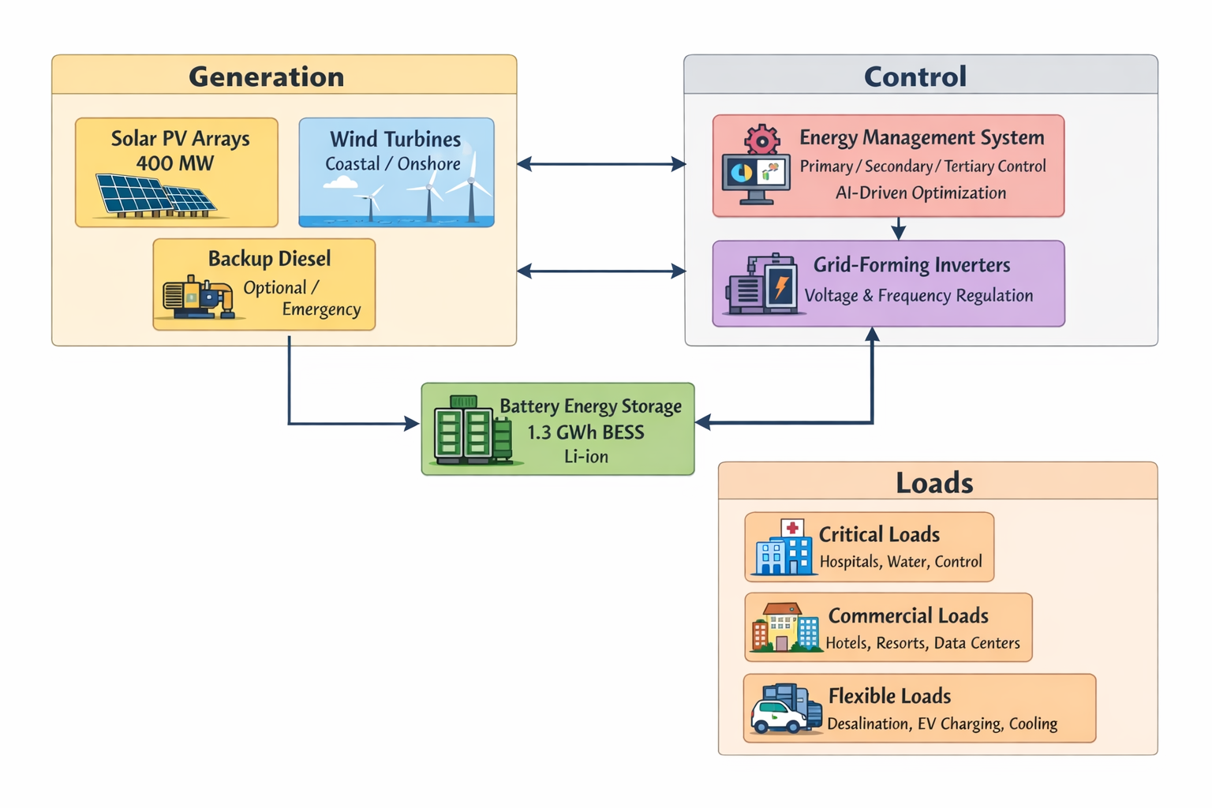
Figure 2: Vision 2030 Energy Transition Pathway - Remote Microgrids
Caption: The timeline depicts the energy transition in Saudi Arabia according to Vision 2030, with major points indicated in respect to hybrid microgrid implementation in remote areas. The plan demonstrates a shift from dependence on diesel fuel to a 100% renewable microgrid, designed in line with achieving the target of 130GW renewable energy production capacity and a 50/50 gas and renewable energy composition of electricity by 2030.
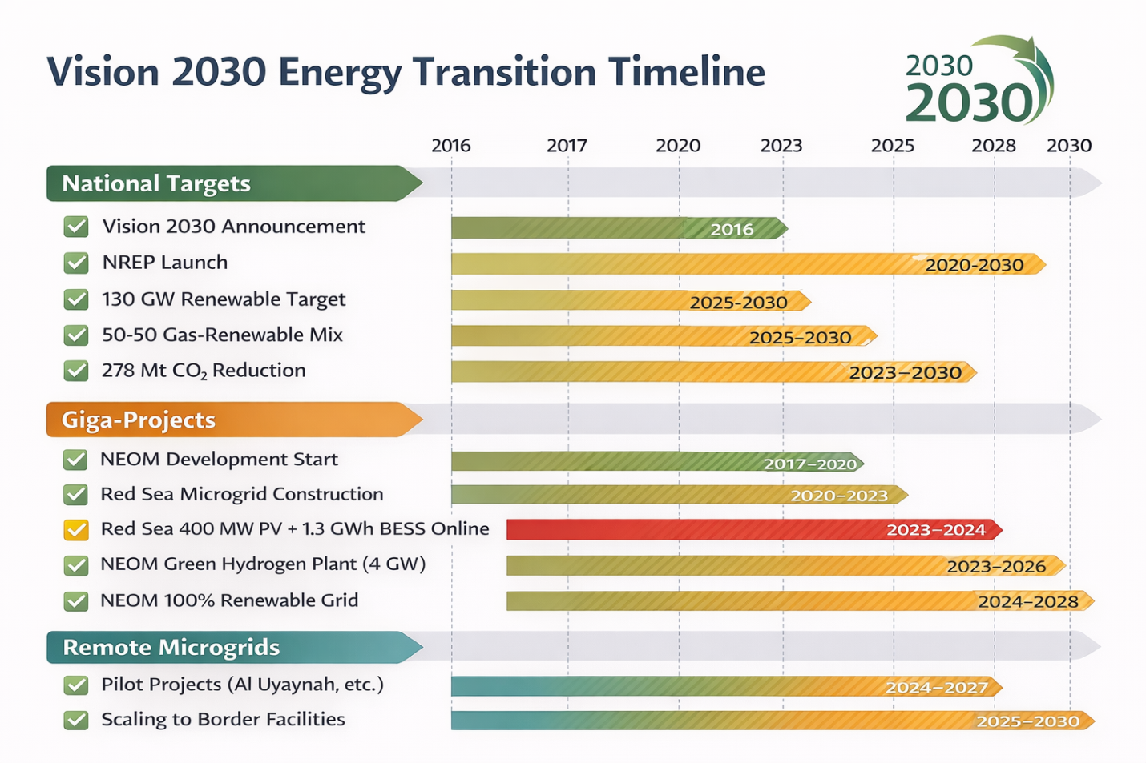

Figure 3: Techno-Economic Comparison of Microgrids Configurations
Caption: Comparison of the Net Present Cost (NPC), Levelized Cost of Electricity (LCOE), Renewable Fraction, and the reduction of carbon emissions for different microgrid scenarios: diesel only, diesel-PV hybrid, PV-battery hybrid, and the full PV-wind-batteries solution, made by combining the performance results of case studies of Con Dao Island in Vietnam, Al Uyaynah in Saudi Arabia, and the Red Sea Project.
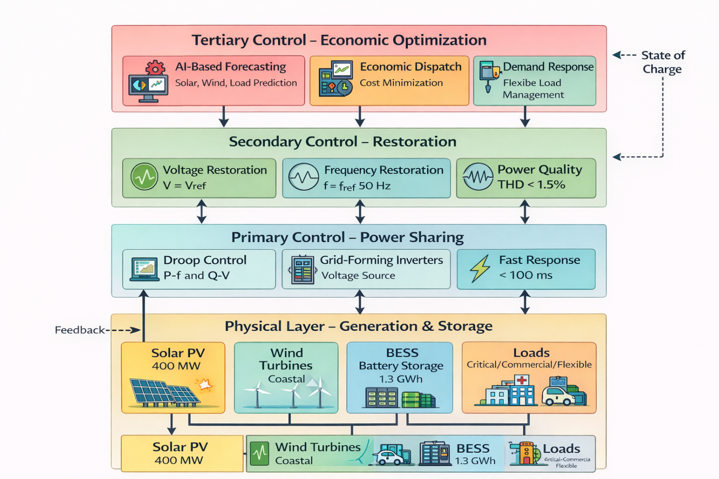

Figure 4: Hybrid Microgrins: Energy Flow Hierarchy Control System
Caption: Comprehensive illustration of the three-tier hierarchical control system implemented in hybrid microgrids, which includes primary, secondary, and tertiary levels with power flow, decision-making, and optimization using AI. This also corresponds to the digital platform in NEOM or the Red Sea microgrid control system by Huawei.
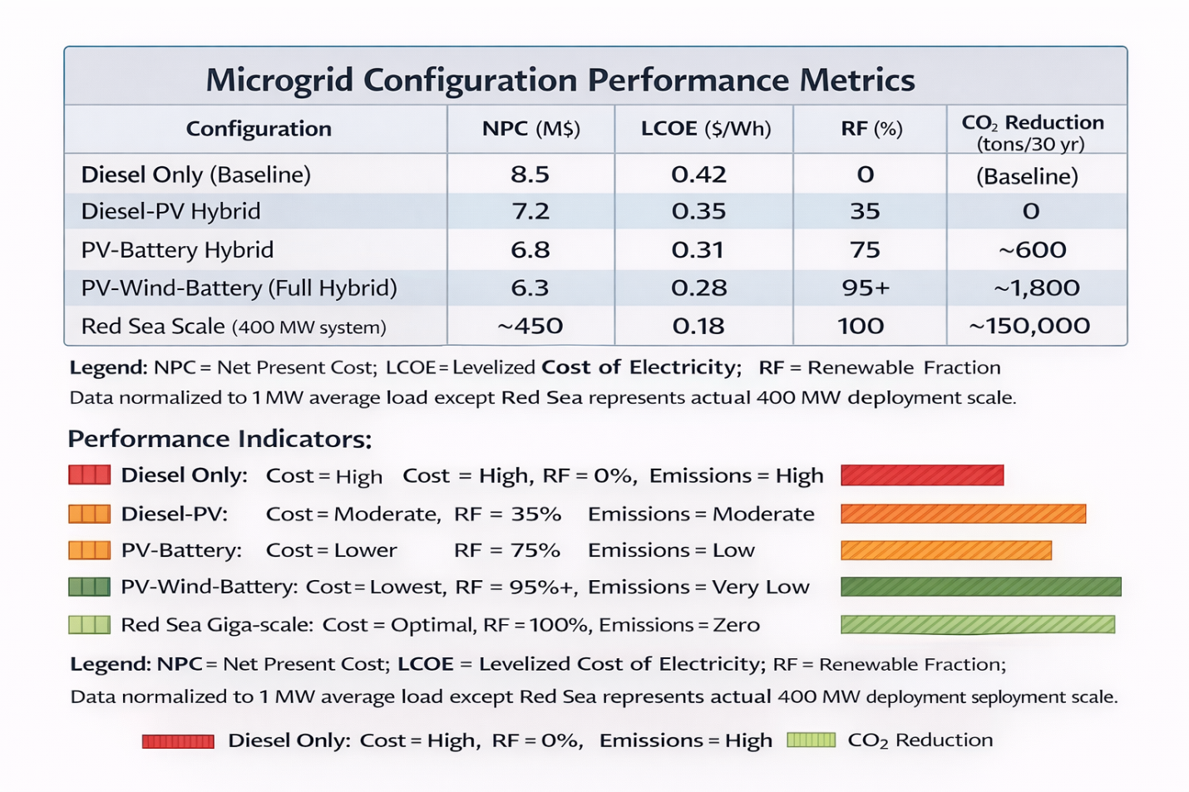

Table 1: Comparative Analysis of Key Microgrid Projects and Case Studies
Caption: Summary of technical specifications, performance data, and best practices gleaned from hybrid micro-grid projects that have relevance to the Vision 2030 plans in the Kingdom of Saudi Arabia. This includes best practices from international examples (Con Dao) as well as Saudi examples (Red Sea Projects, NEOM, and Al Uyaynah).
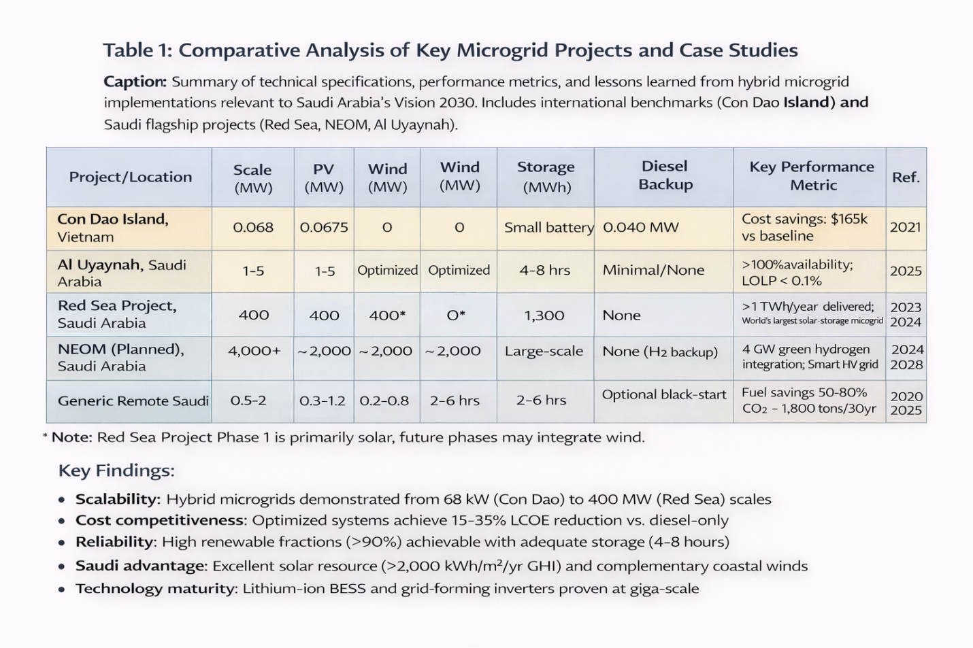

Table 2: Comparative Study of Energy Storage Technology for Desert Microgrids _Caption:_ Technical and economic comparison of the energy storage technologies that can be considered in the context of the extreme desert climate of Saudi Arabia for the application of the NEOM and Red Sea projects.
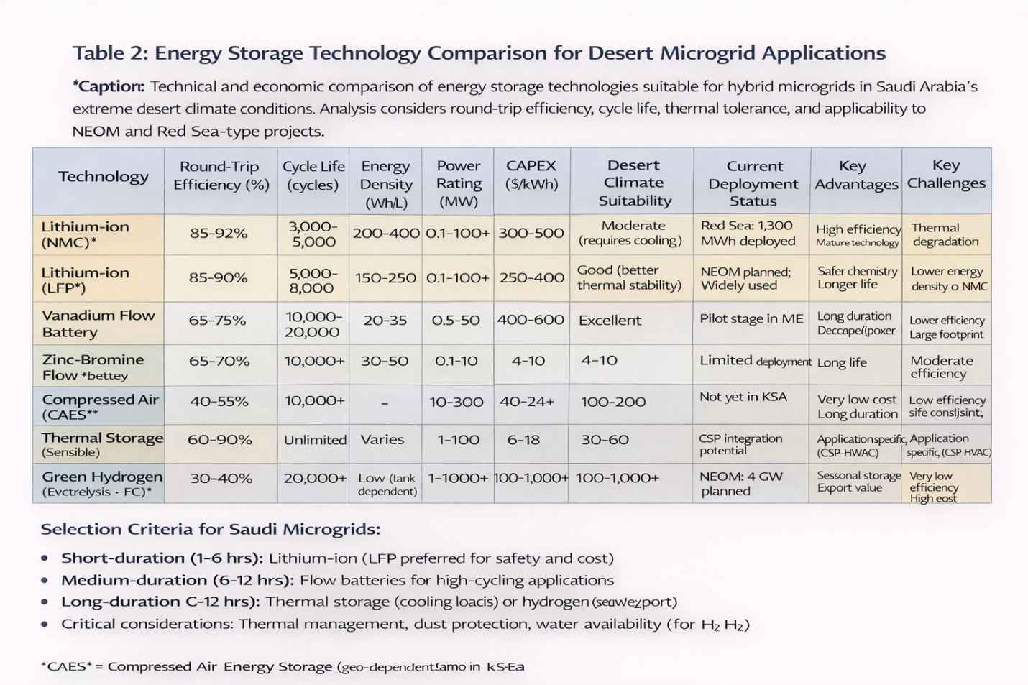

Table 3: Vision 2030 Policy Framework and Microgrid Deployment Roadmap Year
Caption: Hybrid micro-grid deployment strategy and alignment with the Saudi Vision 2030 goals of adding renewable capacity and displacing fossil fuel usage in remote sites depending upon the categories of the sites and the necessary measures by the government.
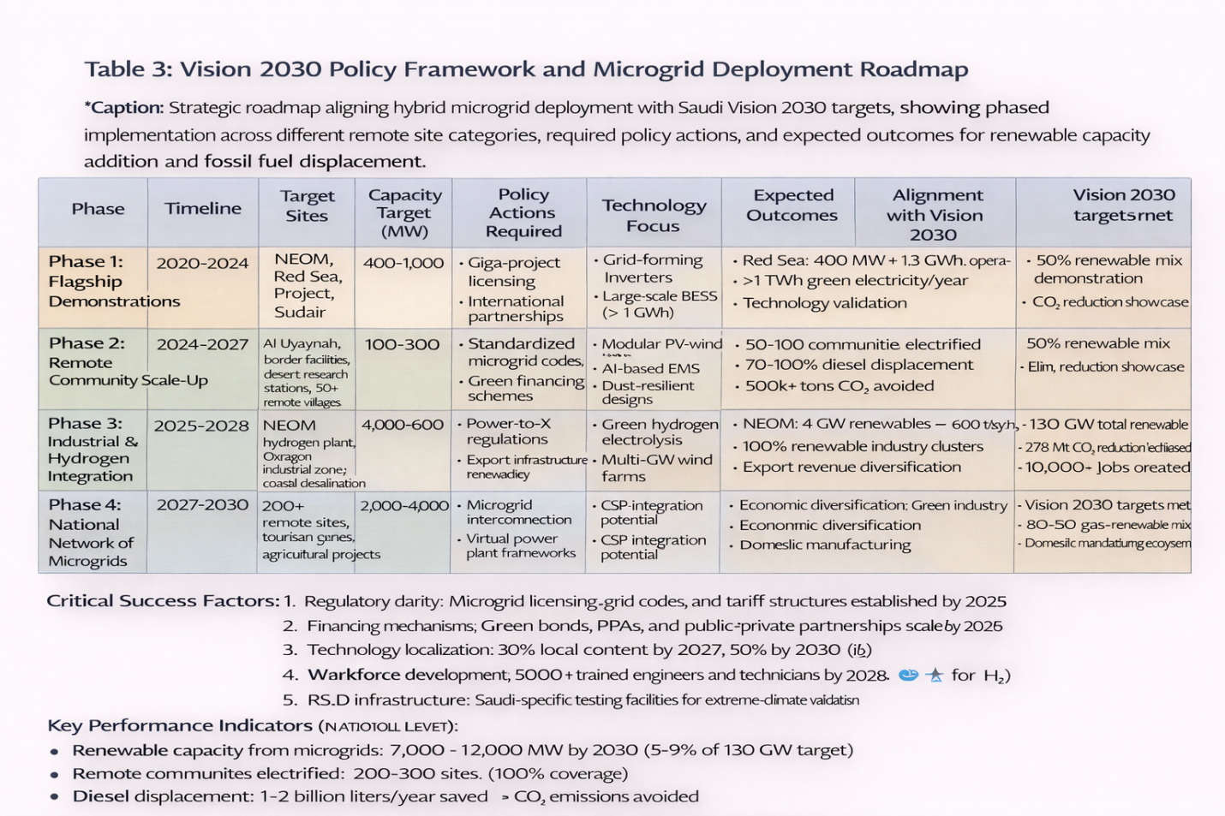

Table 4 : Technical Challenges and Mitigation Strategies in a Saudi Hybrid Microgrid
Caption: Technical identification and articulation of key technical challenges in hybrid micro-griding in Saudi Arabia’s harsh desert and sea climate, and ways to address these through proven and upcoming solutions from experience in Red Sea Project development, NEOM, and world-class models and improvements.

